Program Exit Assessment Project

Statistics for Computer Science – 201-H02-HR

Instructions: The following tasks will comprise your Program Exit Assessment. The tasks are based on a data set given to you by your professor. For your PEA project I designed a series of tasks that asks you to *think* about how data and statistics are used to address social policy issues. The media and Internet constantly quote numbers and statistics with very little regard to how the results have been determined, interpreted, or how they are repeated. To begin you will need to go to <https://gimletmedia.com/show/science-vs/> and listen to the 3rd and 4th Podcasts, entitled: “Science vs Guns” and “Science vs Gun Control”. As you complete the data analysis outlined in the following three tasks, be prepared to discuss how the results you obtain relate to what you learned from the Podcasts.

The groups of tasks, 1, 2, and 3, will be graded according to the following criteria on a Pass/Fail basis. You must Pass all of the criteria to Pass the Program Exit Assessment.

|  |  |  |  |
| --- | --- | --- | --- |
| Criteria | Expectation | Pass | Fail |
| Modeling | The concepts are applied flawlessly and all conclusions are well-supported by the analysis. |  |  |
| Computation | There are no computational errors. |  |  |
| Organization | All steps are presented in an ordered and logical manner. |  |  |
| Notation | Notation is conventional and accurate. |  |  |
| English | There are no more than two spelling and/or grammar errors. |  |  |
| Critical Thinking/Reflection | Discussion of conclusions show critical thinking, direct links to Science vs. and a reflection on what information we can and cannot get from the analysis. |  |  |

Name:

Comments

**Task 1.**

1. In a few paragraphs (using full English sentences), describe the what, where, when, why, and how of your data set. For each different population given, describe the who in detail.

**The Who:** The number of homicide victims in Canada and the US per year

**The what:** The method used to commit homicide.

**The where:** In Canada and the United States

**The when:** Between 2005 and 2014

**The Why:**

**The How:**

1. Create side-by-side relative frequency bar charts showing your statistic vs year for the total observations for the following comparisons. Create side-by-side relative frequency bar charts showing your statistic vs year for the normalized population data for the following comparisons.
2. Canadian Homicides beside American Homicides
3. Canadian Homicides with Handguns beside American Homicides with Handgun
4. Canadian Homicides with Firearms beside American Homicides with Firearms
5. Canadian Homicides with Firearms beside total Canadian Homicides
6. American Homicides with Firearms beside total American Homicides

In a few paragraphs discuss what these side-by-side relative frequency bar charts show. How does this information compare to what you learned from Science vs?

(c) Treating each year as a data point, construct a 5-number summary for your statistic for each of the following populations.

1. Canadian Handgun Homicides



1. Canadian Total Firearm Homicides



1. Total Canadian Homicides



1. American Handgun Homicides



1. American Total Firearm Homicides



1. Total American Homicides



Write an introductory paragraph preceding your 5-number summaries to describe what you are showing. Does Science vs support what you are showing? Do your results seem appropriate based on what you learned from the Podcasts?

(d) For each of the following population pairs, construct a graphic showing the two indicated boxplots side-by-side and write a paragraph comparing the two distributions.

1. Canadian Total Firearm Homicides versus American Total Firearm Homicides.

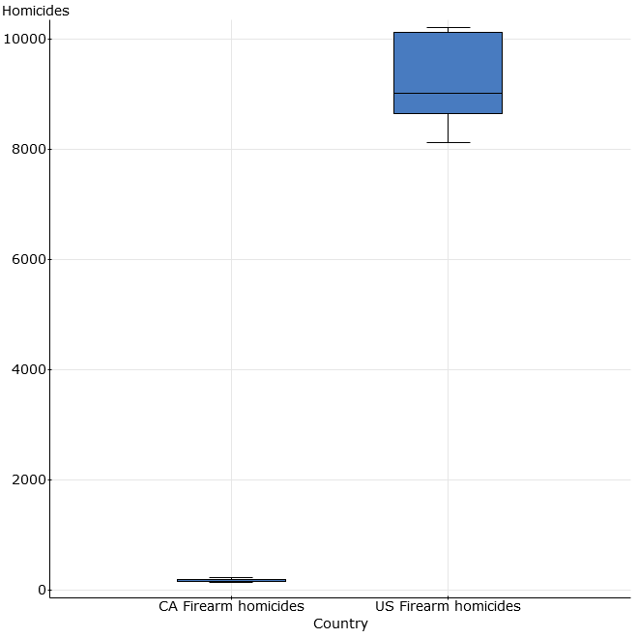

1. Canadian Total Homicides versus American Total Homicides.

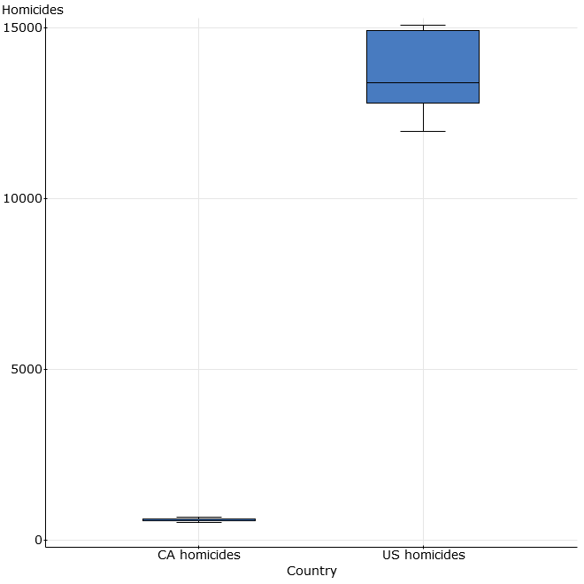

**Task 2.**

1. Create a scatterplot of Canadian Firearm Homicides versus Canadian Homicides using each year as a single data point. Describe the direction, form, and strength of this scatterplot. Discuss whether the Correlation Conditions are met for your scatterplot. Calculate and interpret the resulting correlation coefficient. Determine the equation of the regression line and draw it on your scatterplot. Calculate and interpret the resulting coefficient of determination.
2. Repeat the above steps for the American data.
3. In a few paragraphs discuss the results of this analysis and how they compare to what you learned from Science vs.

**Task 3.**

(a)  Treat all years of Canadian Firearm Homicide rates as a single sample and calculate the sample mean and standard error of your statistic. Repeat this process for American Firearm Homicide rates. Construct a 95% confidence interval for your sample means. Discuss whether or not the necessary conditions are met for a valid confidence interval.

(b) Use the normalized data to determine a success proportion value about Firearm Homicide rates in Canada compared to all Homicide rates. Do the same for the American normalized data. With these success proportions, form a null hypothesis about Firearm Homicide rates in Canada compared to America. Construct an appropriate alternative hypothesis and then perform a hypothesis test with significance levels of 5% and 10%. Write a paragraph explaining the meaning of the significance level, your calculated p-value, whether or not you reject the null hypothesis, and what confidence you have in your alternative hypothesis.